Project Documentation
Streamlining IT Procurement: Automating Standard Laptop Orders with Flow Designer

1. Introduction
- Project Title: Streamlining IT Procurement: Automating Standard Laptop Orders with Flow Designer
- Team ID: SWTID-2026-1259
- Date: 30 September 2026
- Team Members: [Add your team members' names and roles here, e.g. Flow Developer, Catalog Configurator, Tester, Documentation]

2. Project Overview
- Purpose: To automate the handling of standard laptop orders in ServiceNow. Once a Standard Laptop request is approved, a catalog task is generated automatically and assigned to the Hardware team for configuration. This reduces delays, manual overhead and errors, shortens user wait times and makes better use of IT department resources.
- Features:
  - Flow Designer flow 'Standard Laptop task' (Global application, runs as System User) with a Service Catalog trigger.
  - 'Create Catalog Task' action with short description 'Laptop needs to Configured', Assignment group 'Hardware' and Approval 'Approved'.
  - Flow attached to the Standard Laptop catalog item through its Process Engine tab.
  - Approval of the request through the Approvers section, followed by automatic task creation under the Requested Item.

3. Architecture
- Frontend (Service Catalog): Users open Service Catalog > Hardware > Standard Laptop (Lenovo Carbon x1), select optional software (Adobe Acrobat / Photoshop), add additional software requirements and click Order Now. The Order Status page shows the Request Number (REQ).
- Backend (Flow Designer / Process Automation): The flow 'Standard Laptop task' is triggered by the Service Catalog trigger and runs the 'Create Catalog Task' action on the Requested Item. The flow is assigned to the catalog item under Maintain Items > Process Engine.
- Database (ServiceNow tables): Request [sc_request], Requested Item [sc_req_item], Catalog Task [sc_task], Approvals [sysapproval_approver] and the Catalog Item record. A REQ holds one or more RITMs, and each RITM holds its catalog tasks (SCTASK).

4. Setup Instructions
- Prerequisites:
  - A ServiceNow instance (for example a Personal Developer Instance) with administrator access.
  - Flow Designer (Process Automation) and Service Catalog available.
  - The 'Standard Laptop' catalog item (Category: Hardware) and a 'Hardware' assignment group.
- Installation (configuration steps):
  - Open All > Flow Designer > New > Flow. Name: 'Standard Laptop task', Application: Global, Run As: System User > Submit.
  - Add a trigger: Service Catalog > Done.
  - Add an action: Create Catalog Task. Drag the Requested Item record into 'Requested Item', set Short Description 'Laptop needs to Configured', and add fields Description, Assignment group = Hardware and Approval = Approved > Done.
  - Save and Activate the flow.
  - Open All > Maintain Items > Standard Laptop > Process Engine, remove other automations, add the Flow 'Standard Laptop task' and save the record.

5. Folder Structure
ServiceNow is a configuration-based platform, so there are no client/server code folders. The solution is organised as the following records:
- Client (user-facing side): Service Catalog > Hardware > Standard Laptop item (item form, optional software, Order Now), the Request / Requested Item forms and the Catalog Task form.
- Server (platform side): Flow Designer > Flows > 'Standard Laptop task' (trigger and action); Maintain Items > Standard Laptop > Process Engine (flow assignment); tables sc_request, sc_req_item and sc_task.

6. Running the Application
- Open Service Catalog > Hardware > Standard Laptop and click Order Now.
- Open the Request Number from the Order Status page and, in the Approvers tab, right-click the approval record and choose Approve.
- Open the Requested Item and check the Catalog Tasks tab: a task assigned to the Hardware group with the short description 'Laptop needs to Configured' appears.
- Open the catalog task to verify the short description, description, assignment group and approval fields.

7. API Documentation
No custom APIs or scripts were developed for this project; the automation uses built-in ServiceNow features (Flow Designer, Service Catalog and Process Engine). If needed, the generated records can be read with the platform's standard Table API, for example:
GET /api/now/table/sc_task?sysparm_query=request_item.number=RITM0010001
GET /api/now/table/sc_req_item?sysparm_query=request.number=REQ0010001
The response is a JSON list of matching records (fields such as number, short_description, assignment_group and approval). Access depends on the user's roles.

8. Authentication
- Users sign in to the ServiceNow instance with their own credentials and access is controlled by roles and ACLs.
- The requester orders from the Service Catalog; the approver (shown in the Approvers tab) approves or rejects the request; the Hardware group works the resulting catalog task.
- The flow runs as 'System User', so task creation does not depend on the requester's permissions.

9. User Interface
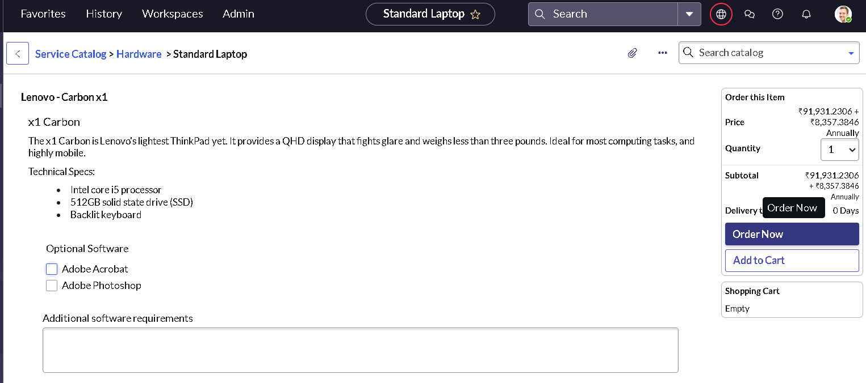
Figure 1: Standard Laptop catalog item with Order Now button
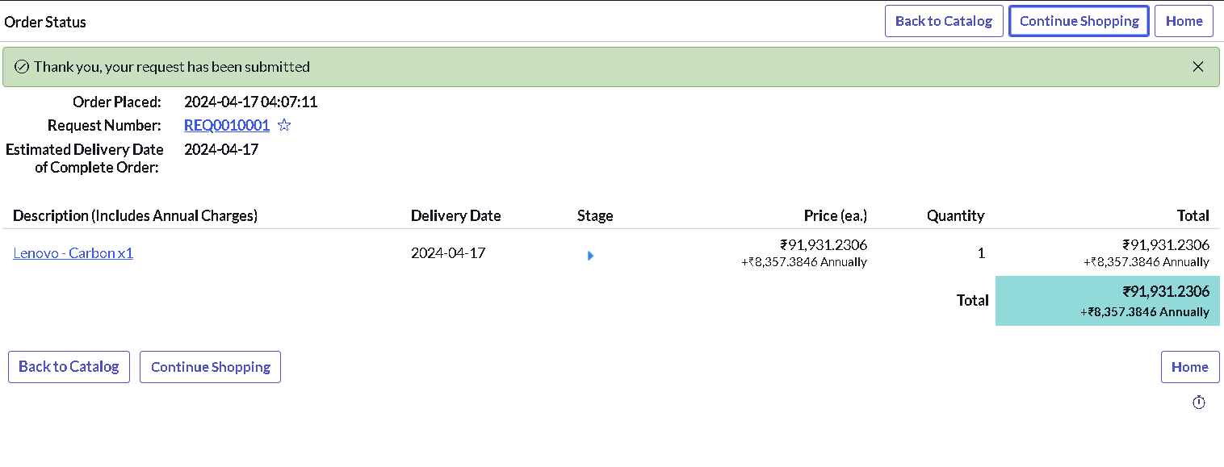
Figure 2: Order Status page showing the Request Number
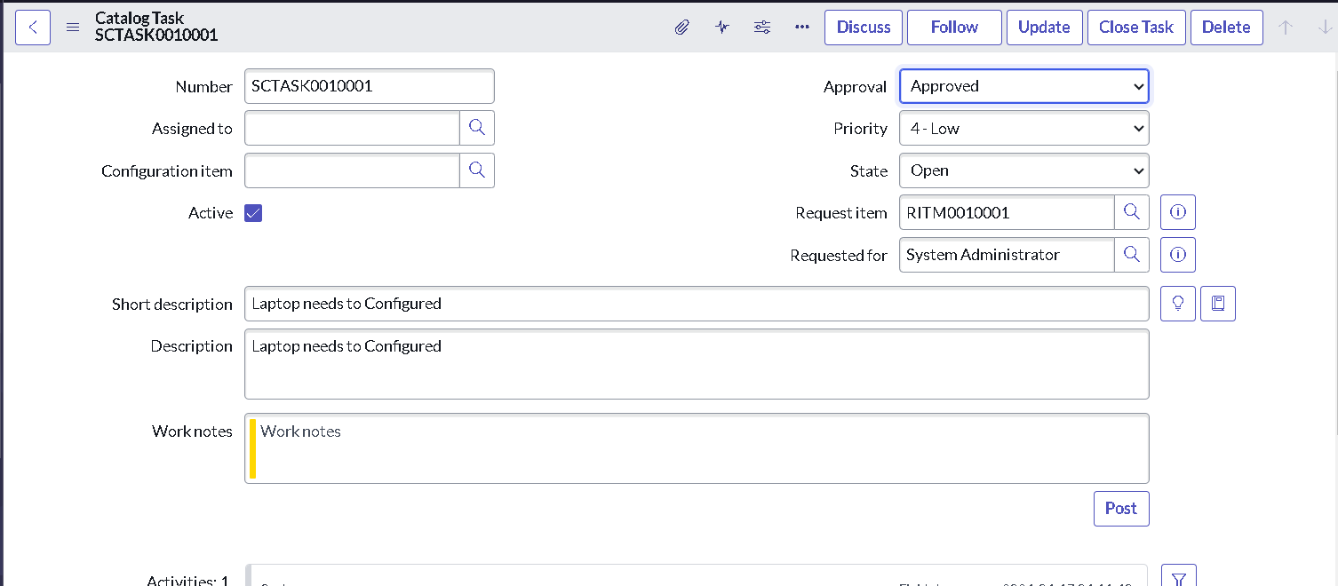
Figure 3: Catalog Task generated by the flow

10. Testing
Testing was done manually, end to end, in the ServiceNow instance:
- Place an order for Standard Laptop and confirm that a REQ and RITM are created.
- Approve the request and confirm that a catalog task (SCTASK) is created under the RITM.
- Verify the task values: short description 'Laptop needs to Configured', Assignment group 'Hardware', Approval 'Approved'.
- Check the flow run in Flow Designer (Executions) and use the Test option of the flow when troubleshooting.

11. Screenshots or Demo
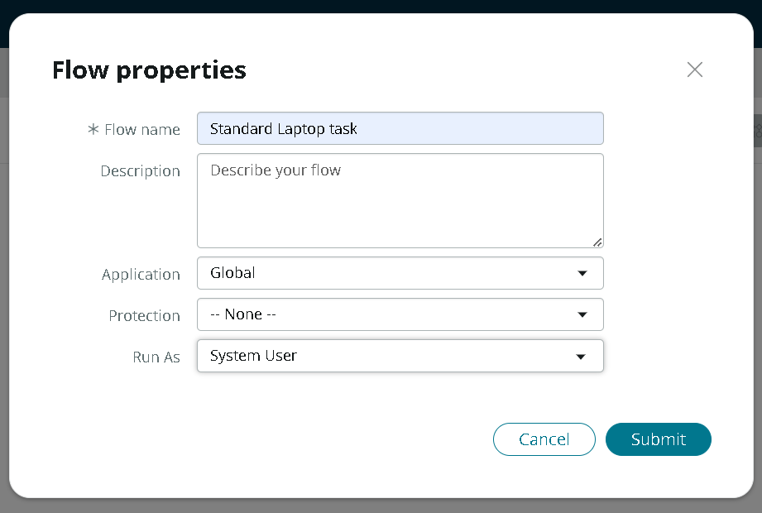
Figure 4: Flow properties (Standard Laptop task, Global, System User)
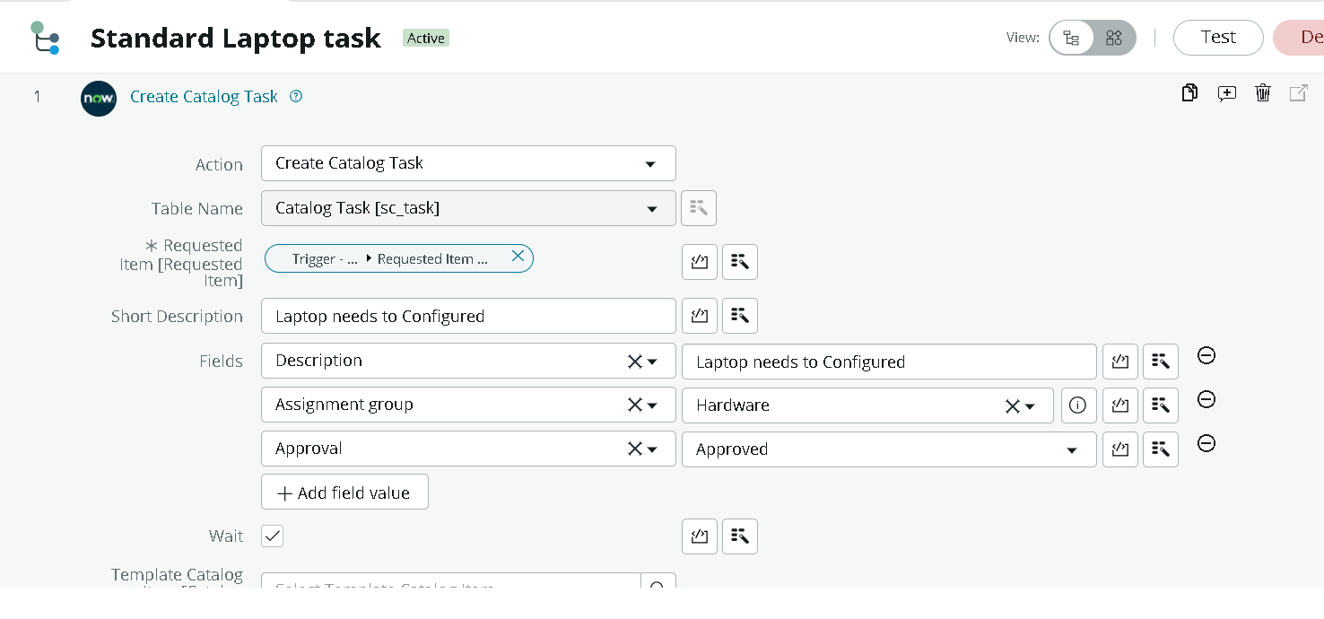
Figure 5: Create Catalog Task action configuration
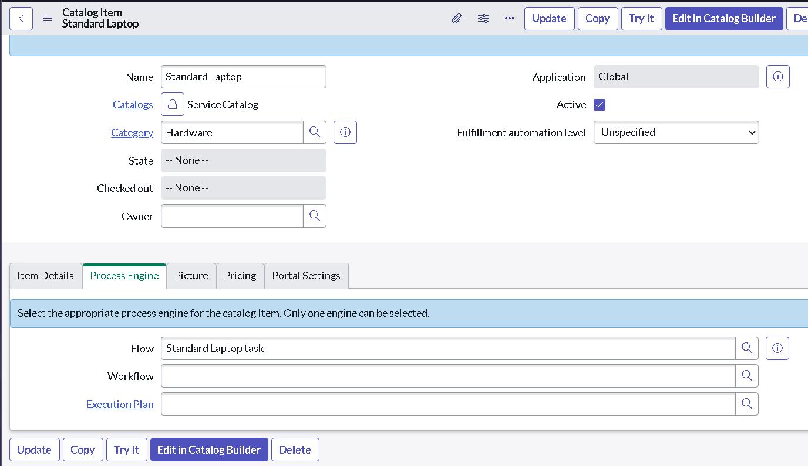
Figure 6: Flow assigned to the Standard Laptop item (Process Engine)
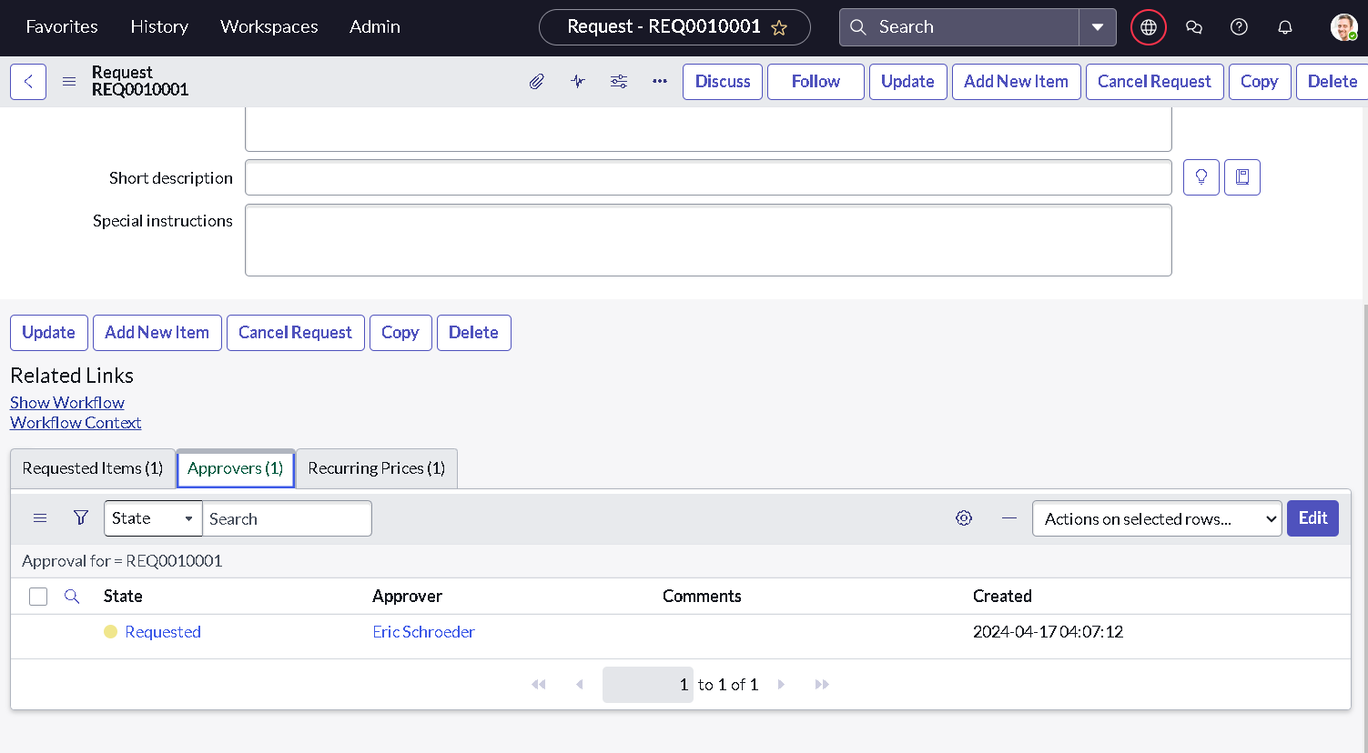
Figure 7: Approvers section of the request
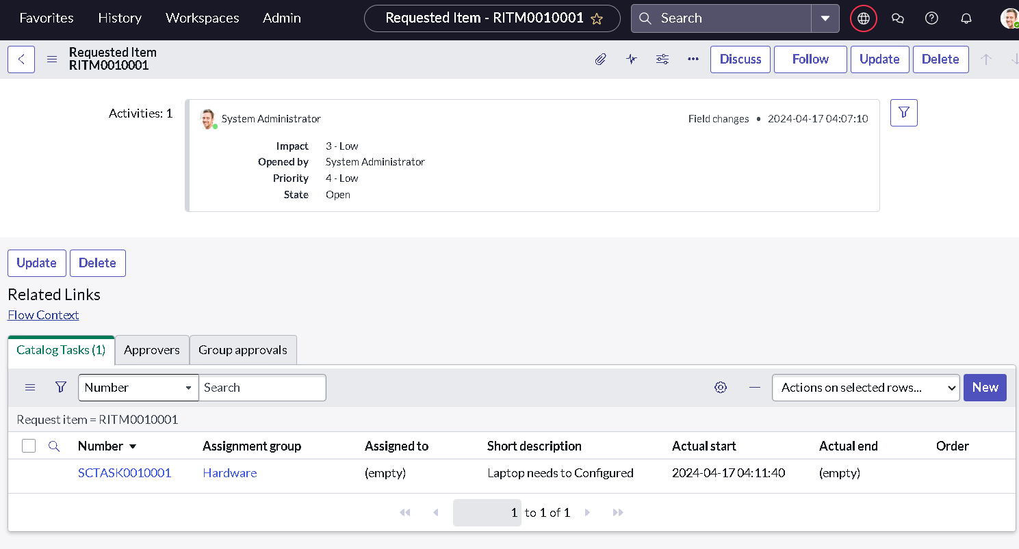
Figure 8: Requested Item with the generated catalog task

12. Known Issues
- The short description is created exactly as specified ('Laptop needs to Configured') and can be reworded if a different text is preferred.
- The flow assigns the task to the Hardware group only; an individual technician is not assigned automatically.
- The Approval field on the catalog task is set to a fixed value ('Approved') and the flow covers standard laptops only.

13. Future Enhancements
- Send email or notification to the requester and the Hardware team when a task is created or completed.
- Auto-assign the task to a technician based on workload, and add SLA timers for configuration time.
- Reuse the flow for other catalog items (monitors, mobiles, accessories) and add reports or dashboards on procurement turnaround.

